MDM2 – Case Study: Assistive Robotics for
Improvement of Life Quality
One‑Page Proposal

Team | Group - 2
Members | Ankith Bettaswamy Gowda (22511178)  Rohan Rangaraju (22507090)
Project Title | An Intelligent Telepresence Companion System
GitHub Repository URL | https://github.com/RangarajuRohan/Assistive-Robotics
Contact Email | rohan.rangaraju@stud.th-deg.de
Industrial Application (target domain/use‑case) | Healthcare and assistive robotics, specifically in home care services and remote patient monitoring. The system can be deployed by healthcare providers, nursing agencies, and assisted living facilities to improve caregiver efficiency, enable remote consultations, and enhance patient engagement in home environments.
Keywords (3–6) | • Telepresence Robotics  • Home Healthcare  • Remote Monitoring  • Assistive Technology  • Human-Robot Interaction  • Healthcare Logistics Optimization
Submission Date (YYYY‑MM‑DD) | 2026-04-10
Gant Chart | 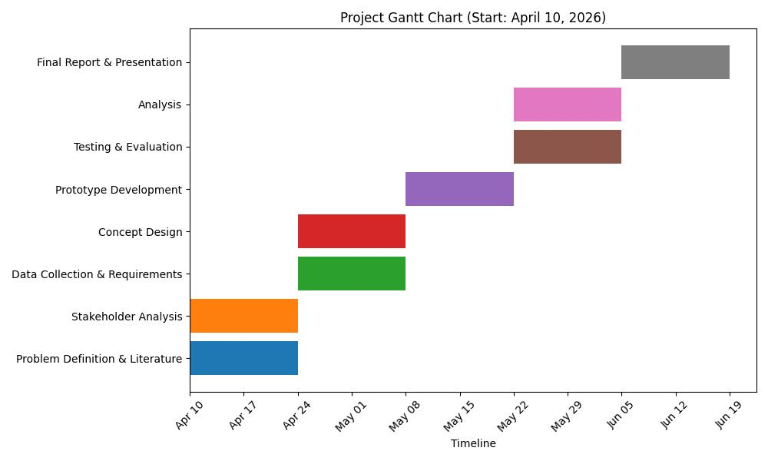

1) Problem Statement & Measurable Outcomes (3–4 sentences) | Home care services face significant logistical challenges due to reliance on in-person visits, resulting in high travel time, increased operational costs, and delayed response to patient needs. Caregivers are limited in how many patients they can support daily, reducing system efficiency. This project addresses these production/logistics inefficiencies by introducing a telepresence companion that enables remote monitoring and interaction.  Measurable outcomes: reduction in caregiver travel time, faster response to patient needs, increase in patient coverage per caregiver, and improved user satisfaction.
2) Motivation & Assistive Relevance (2–3 sentences) | Elderly individuals, patients with disabilities, caregivers, and healthcare providers benefit from more accessible and efficient care delivery. The system creates value by reducing costs, improving response times, and enhancing patient independence and emotional well-being. This is especially important now due to aging populations, increasing demand for home care, and shortages in healthcare staff.
3) Related Work Snapshot (2–3 key references) | • Telepresence systems like Double Robotics Telepresence Robot enable remote presence but lack integration with care logistics.  • Beam Telepresence Robot supports communication but offers limited personalization and workflow optimization.  • Smart home healthcare IoT systems provide monitoring but lack real-time interactive support.
4) Method & Feasibility (≤6 sentences) | The study will collect data from academic sources (Google Scholar, IEEE Xplore), case studies, and user feedback from caregivers and patients. A structured search protocol will use keywords like telepresence healthcare and home care systems, focusing on recent and high-impact studies. The analysis will compare existing solutions and identify inefficiencies in care delivery workflows. A prototype telepresence system (video interface + remote control features) will be developed. Expected artifacts include a system architecture diagram, workflow model, and usability evaluation report. The project is feasible using existing hardware (cameras, mobile devices) and software tools within the course timeline.
5) Milestones & Timeline (short table/list) | • P1 (Week 1–2): Problem definition, literature review, stakeholder analysis  • P2 (Week 3–4): Data collection, requirements specification, concept design  • P3 (Week 5–6): Prototype development (telepresence interface)  • P4 (Week 7–8): Testing, evaluation, and analysis  • P5 (Week 9–10): Final report, refinement, and presentation
6) Risks & Ethics (1–2 sentences) | The project must address data privacy concerns related to video/audio monitoring and ensure informed user consent. Ethical considerations include proper citation of sources, minimizing bias in data collection, and ensuring the system remains practical and accessible within technical constraints.

Phase 1 rubric (15%): Team & GitHub (2%), On‑time (2%), Topic & Proposal (5%) — Industrial Application, Problem+Outcomes, Feasibility+Timeline; Presentation (6%).

